Mainpage -navbar
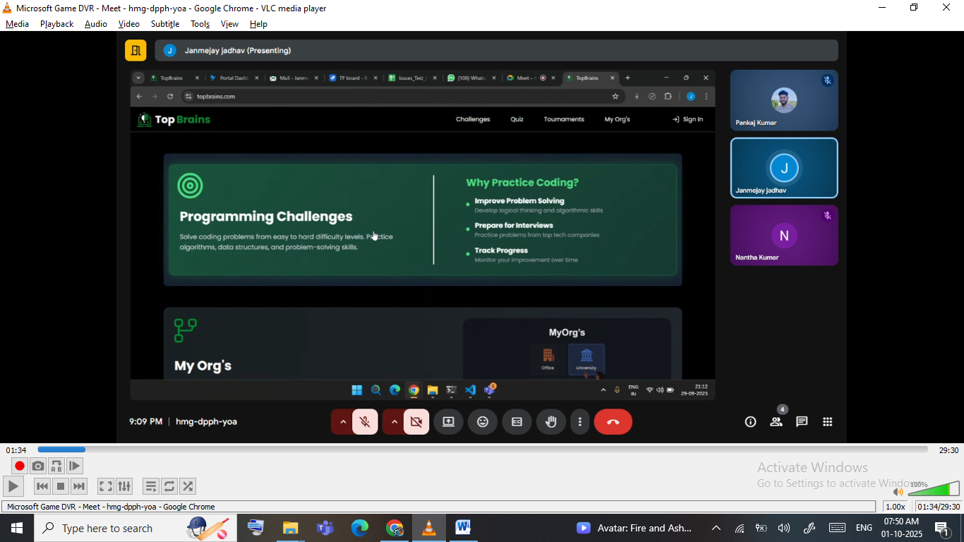

- Challenges –like leetcode
- Quiz
- Tournaments
- My Orgs

Sign in

1.challenges

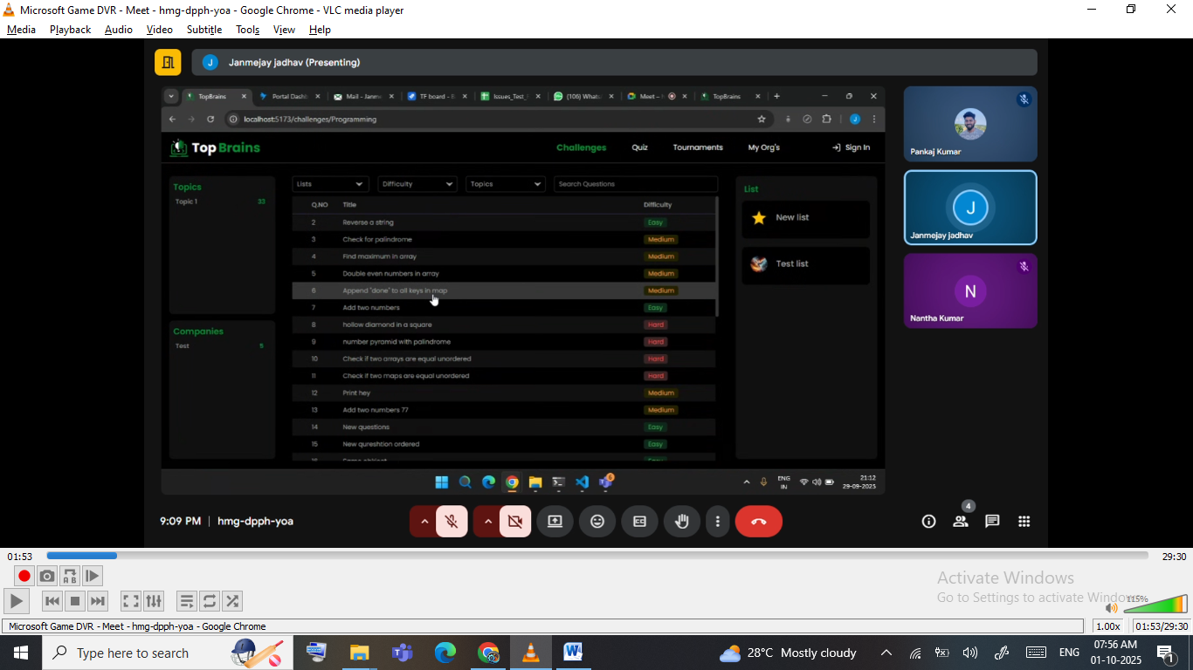

Here user can see all type of question
Category :We have divided in separate categories
  - Topics
  - Companies- if they are associated with companies

Filter & search: user will get some option filter & search
Filter based on
  - List
  - Difficulty
  - Topics

If we click on one question ->user will navigate to page

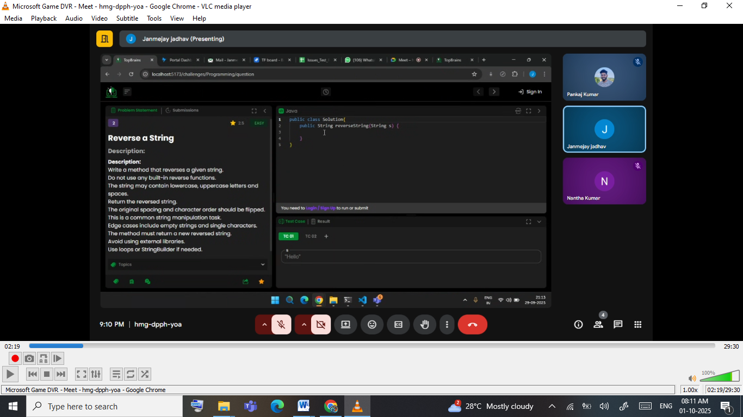

Here we will get the interface like leetcode coding platform

